Task 1:

1. Entity team:

* Each team may or may not have an assigned coach
* Each team has minimum amount of player is 1, and maximum is 12 players.
* Each team can have maximum amount of coaches is 3

1. Entity player:

* Each player is registered by at least 1 parent
* Each player belongs to only one team

1. Entity parent:

* Each parent can register at least 1 player

1. Entity coach:

* Each coach may have one of following specialty: OFFENSIVE, DEFFENSIVE, or PHYSICAL.
* Each coach can be assigned to only one team.

Task 2:

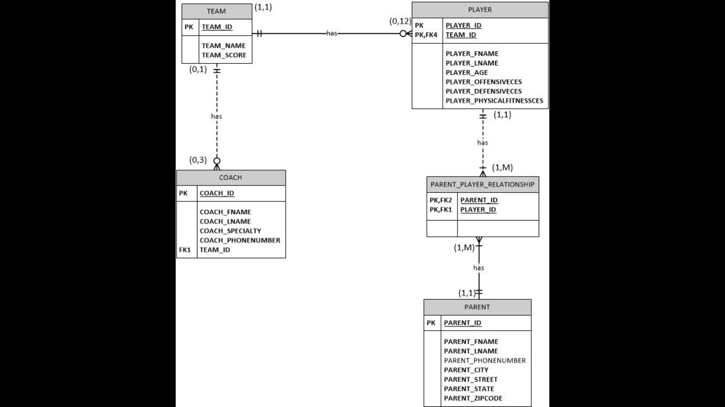

Task 3:

|  |  |  |  |  |  |  |  |  |  |
| --- | --- | --- | --- | --- | --- | --- | --- | --- | --- |
| Table Name | Attribute Name | Contents | Type | Format | Range | Req’d | PK/FK | FK Refered Table | Indexes (I)/Unique (U) |
| TEAM | Team_name | The name of the team | Text |  |  | Y | PK |  |  |
| Team_id | Id number of team | Number(10) |  |  | Y |  |  |  |
| Team_score | Team score ( shows the chance of winning at major games/competitions) | Number |  | 1-100 | Y |  |  |  |
| Coach_id | Id of the coach | Number(10) |  |  | Y | FK1 | Coach |  |
| Player_id | Id of players | Number(10) |  |  | Y | FK2 | Player |  |
| PLAYER | Player_id | Id of a player | Number |  |  | Y | PK |  |  |
| Player_fname | First name of a player | Text |  |  | Y |  |  |  |
| Player_lname | Last name of a player | Text |  |  | Y |  |  |  |
| Player_age | Age of a player | Number(2) |  |  | Y |  |  |  |
| Player_offensiveces | Offensive current estimated score | Number(2) |  | 0-100 | Y |  |  |  |
| Player_defensiveces | Defensive current estimated score | Number(2) |  | 0-100 | Y |  |  |  |
| Player_physicalfitnessces | Physical fitness current estimated score | Number(2) |  | 0-100 | Y |  |  |  |
| Team_name | Name of a team | Text |  |  | Y | PK, FK1 | Team |  |
| COACH | Coach_id | Id of a coach | Number |  |  | Y | PK |  |  |
| Coach_fname | First name of a coach | Text |  |  | Y |  |  |  |
| Coach_lname | Last name of a coach | Text |  |  | Y |  |  |  |
| Coach_specialty | Shows the special of a coach in which place a player in a match | Text |  | Offensive, Defensive, or Physical | Y |  |  |  |
| Coach_phonenumber | Phone number of a coach | Number(10) |  |  | Y |  |  |  |
| Team_name | Name of a team | Text |  |  | Y | FK1 | Team |  |
| PARENT | Parent_id | Id of a parent | Number |  |  | Y | PK |  |  |
| Parent_fname | First name of a parent | Text |  |  | Y |  |  |  |
| Parent_lname | Last name of a parent | Text |  |  | Y |  |  |  |
| Parent_phonenumber | Phone number of a parent | Number |  |  |  |  |  |  |
| Parent_street | Street where a parent lives | Text |  |  | Y |  |  |  |
| Parent_state | State where a parent lives | Text |  |  | Y |  |  |  |
| Parent_zipcode | Zip code of the city where a parent lives | Number |  |  | Y |  |  |  |
| Parent_city | City where a parent lives | Text |  |  | Y |  |  |  |
| PARENT_PLAYER_RELATIONSHIP | Parent_id | Id of a parent | Number |  |  | Y | PK,FK1 | Parent |  |
| Player_id | Id of a player | Number |  |  | Y | PK,FK2 | Player |  |